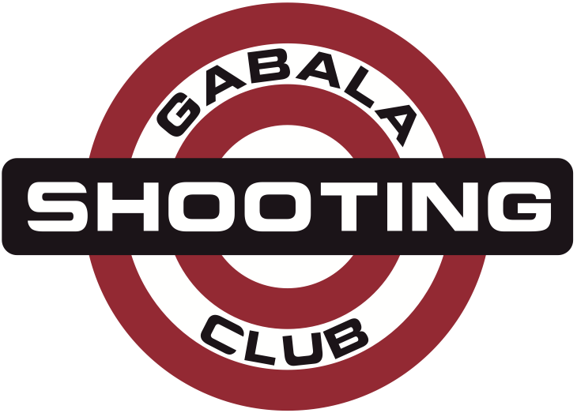
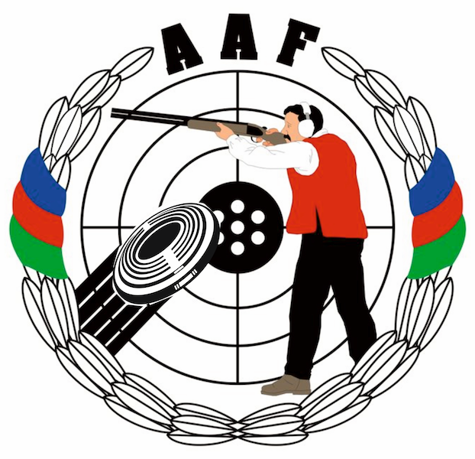
HEYDAR ALIYEV
INTERNATIONAL GRAND PRIX
Gabala, Azerbaijan
14 – 21 August 2014

FINAL ENTRY FORM |  |  | Shotgun |  |  |  | Please return by |  |  |  | 15 JULY 2014 |  |  | to Organizing Committee
name of federation |  |  |  |  |  |  | nation code |  |  |  |  |  |  | Lermontov str. 68  Baku, AZ1066, Azerbaijan  Phone: +994-50-5141515  Phone : +994-55-7537775  E-mail: info@gabala.eu
contact person |  |  |  |  |  |  | phone number
e-mail address |  |  |  |  |  |  | fax number
no | Athletes |  |  |  | Date of birth |  |  |  | Men |  |  |  | Women |  | Junior Men
no | family name |  |  | first name | DD | MM |  | YY | TR125 |  |  | SK125 | SK75 | TR75 | TR125 | SK125

